Nepal College of Information Technology
Balkumari Lalitpur
Unit Test Spring Semester 2008

Engineering Math-IV
Year: 2008 FM: 60
Sem: IV PM: 30
Program BE Time: 2hrs

Attempt all the questions:

1. a) Define Fourier Integral 8
Show that 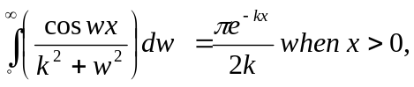k>0
b) Let f(x) and g(x) be piecewise continuous, bounded and absolutely integrable on the x-axis , then 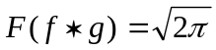 F[f(x)] F[g(x)]. 7

OR
Define Fourier transform. Find Fourier Sine transform of 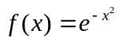.
2. a) Find Fourier Cosine transform and Fourier transform of 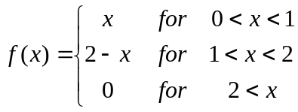 8
b) Define Z-transform, Show that Z(t^{k}) =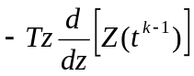. Use it to find Z(t) and Z (t²). 7
3. a) State and prove first shifting theorem of Z-transform. Use it to find Z (e^{-iat}) and hence deduce the values of Z (cosat) and Z (sinat). 8
b) Find Inverse Z-transform of 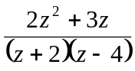 7

4. a) Solve using Z-transform 7
b) Express in the form x + iy: 4
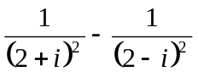
c) Express in the polar form (modules amplitude form):-
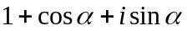 4

